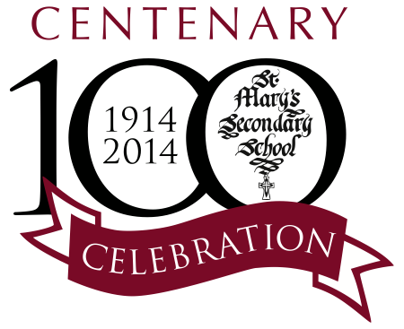

**School Uniform**

School Uniform must be worn during the school day, on school related activities and travelling to and from school.

***Junior Cycle Students (1st – 3rd Year)***

* Royal Blue V-neck pullover with long sleeves and crest inset
* Royal Blue Skirt – inverted pleat and knife pleat on either side at the front and plain back
* White shirt
* School Tie
* School Jacket
* Stockings: Black or grey knee socks or tights
* Footwear: Low heeled black shoes. Black decks acceptable.

**Runners not allowed except for P.E./Clubs**

***Senior Cycle Students (TY – 6th Year)***

* Black Senior School V-neck pullover with long sleeves and crest inset
* Royal Blue Skirt – inverted pleat and knife pleat on either side at the front and plain back or
* Plain Black trousers – **Black denim jeans or tracksuit bottoms not allowed**
* White Shirt
* School Tie
* School Jacket
* Stockings: Black or grey knee socks or tights
* Footwear: Low heeled black shoes. Black decks acceptable.

**Runners not allowed except for P.E./Clubs**

***The School Uniform is supplied by the following:***

Sixty Three, 63 Kenyon Street, Nenagh

Slatterys, Pearse Street, Nenagh

**NB: Please ensure that your daughter’s full name is clearly marked on her uniform especially her School Jacket.**

Leaving Certificate and Junior Certificate students are reminded that full uniform, in good condition, is mandatory until the end of the State Exams.