ADMISSIONS POLICY

2018/2019

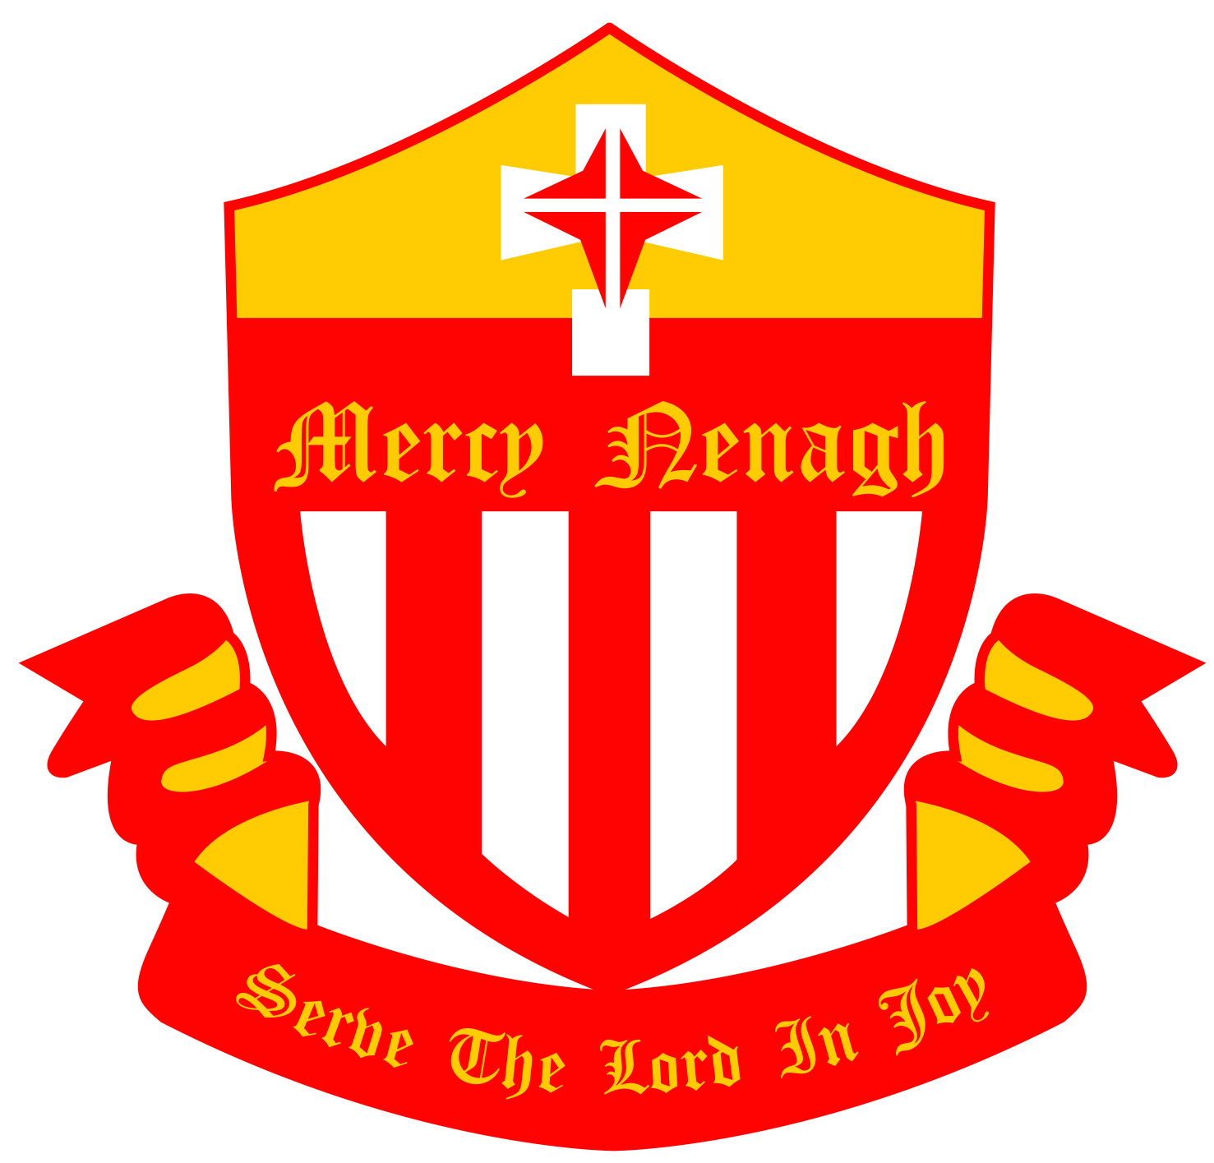

St. Mary’s Secondary School,
Nenagh
Co. Tipperary
ADMISSIONS POLICY

Introduction

History

The Sisters of Mercy founded an Intermediate School in Nenagh in 1913. In 1929 the school was formally renamed St. Mary’s Secondary School and the Leaving Certificate was offered for the first time.

St. Mary’s Secondary School

St. Mary’s Secondary School is a Catholic all girls’ school under the Trusteeship of CEIST (Catholic Education an Irish School’s Trust). The school caters for 600 girls. It is an inclusive community with students, teachers, non-teaching staff, parents, Board of Management and Trustees interacting collaboratively. Our school aims to provide each girl with a holistic education built on respect. We have a strong commitment to the excellence required for each student to reach her full potential as a uniquely gifted and precious human being.

Aims of St. Mary’s Secondary School

Aims

- An environment shall be provided in which each student can live out her Christian commitment with opportunities for prayer, worship and a deeper understanding of the Christian way of life.

- Quality teaching and learning shall ensure strong academic achievement.

- A warm, friendly, cooperative climate, with mutual respect and a team approach to problem solving, shall be present.

- St. Mary’s Secondary School supports respect for diversity of traditions, values, beliefs, languages and ways of life in society. Special care shall be given to weak or marginalized.

- Students shall be prepared for life and for relationships, learning respect for others and for the environment. Talents for the creative use of leisure shall be cultivated.

- A comprehensive Careers Guidance Service shall facilitate the formation of life goals and career plans.

- Involvement of all partners in the education process shall be welcomed and encouraged.

- Opportunities shall be provided for the personal/professional development of staff and for the affirmation of their commitment and dedication.
Faith Development

The challenging task of handing on the faith is one that is shared by family, parish, and school. In St. Mary’s, Religious Education is supported by a Chaplain. Retreats, liturgies, fundraising for charities and guest speakers are an integral part of the programme. Our students are encouraged to be reflective and active young Christians, with a commitment to core gospel values. The school aims to promote respect for different faiths, fostering inclusion and understanding.

Students of other faiths who are not attending religious education classes during timetables RE classes will be required to remain in the RE classroom under the supervision of the RE teacher.

Current Legislation

St. Mary’s Secondary School, Nenagh fully subscribes to and operates within current legislation and endeavours to ensure that best practice prevails in all aspects of the work of the school.

The basic principles of current education legislation are reflected in the School’s Mission statement, i.e. partnership, accountability, transparency, inclusion, diversity, parental choice, equality of participation and access.

In its structures and policies, St. Mary’s Secondary School will ensure that these principles are respected and implemented.

School Structures

Location and Facilities

St. Mary’s Secondary School is located in the centre of the town of Nenagh.

The school is equipped with a number of specialist rooms and is capable of accommodating up to 600 students for, Art, Home Economics, Science, Technology, Tech Graphics, Music, Video and Recording, Guidance and Counselling and Resource.

St. Mary’s Secondary School has modern information technology facilities and Internet access is widely available.

There is also an extensive administration block, a modern Library, a spacious Concert Hall and a modern PE Hall.
Management Structure

St. Mary’s Secondary Scholl managed on behalf of the Trustees, the Board of Management, who is legally responsible for the operation of the school, representing the trustees, staff and parents. The Principal administers the school on behalf of the Board of Management. The Board consists of:

- 4 Nominees of the Trustees/CEIST
- 2 Nominees of the Teaching Staff
- 2 Nominees of the Parents’ Body
- The Secretary to the Board of Management is the Principal

School Organisation

St. Mary’s Secondary School has a strong ethos of care for all students. The personal and social development and well being of each student is central to our philosophy of education.

The following structures are in place:

- Tutor for each class
- Year Head for each group
- Buddy system
- Senior Prefects

The Principal, Deputy Principal, Guidance Counsellor and Chaplain work in close co-operation with the Class Tutors and the Year Heads.

Curriculum

St. Mary’s Secondary School has a long tradition in Curriculum innovation. We offer a wide variety of programmes, which aim to develop the unique talents and abilities of each individual student.

Current Programmes available in our school are:

- Junior Certificate
- Transition Year
- Leaving Certificate Established
- Leaving Certificate Applied
- Leaving Certificate Vocational
- A Resource class, which incorporates FETAC modules and Junior Certificate subjects at foundation level.
Parents’ Council

At the beginning of each school year, the Parents’ Body elects two representatives from the different areas in the catchment region.

Students’ Representative Council (SRC)

Each class has an elected representative on the Students’ Representative Council (first introduced in 1976). It is presided over by the Student President, elected by the student body. There are two teachers on the Council, one nominated by the staff and the second is nominated by the Principal.

Extra Curricular Activities

All students are encouraged to take part in extra-curricular activities. There is a full range of artistic, cultural, religious and sporting activities available in St. Mary’s.

Opening Hours

Our teaching day begins at 9.00am and finishes are 3.35pm. At beginning and end of each school day, students are supervised. Students are supervised from 8.45am at the beginning of the day and until 3.35pm at the end of the day.

School Calendar

Each year parents receive a school calendar detailing school holidays, parent/teacher meetings and other important events.

Voluntary Contribution

In order to provide a quality and varied education, the Board deem it necessary to request a voluntary contribution from all Parent(s)/Guardian(s). The Board of Management reserves the right to review the voluntary contribution on a year to year basis.

Application Process

- Communication will be made with each Primary School in the catchment area to distribute information about our School.

- Application Forms and copies of the School Prospectus are distributed in each Primary School. Extra copies are left with the Primary School Principal for distribution to students who are absent.

General Requirements for all students applying

Eligibility

To be eligible for admission to the School, a student must be female and have reached 12 years of age on 1st January in the calendar year following the student’s entry into the School.

It will be expected that the student will have completed sixth class in Primary School or an equivalent standard in another jurisdiction.

Application forms for prospective pupils over the age of 18 will be considered on an individual basis by the Board of Management.

Requirements

As part of the Admissions Process, Parent(s)/Guardian(s) will be required to:

- Complete an Application Form and submit it before the closing date.

- Ensure that all the required information is submitted to the School – Birth Certificate, 2 recent Passport Photographs, etc.

- Attend the School’s Information Evening with the prospective student.

- Accept the School Ethos

- Accept the School Code of Behaviour

Assessment Test

A Cognitive Assessment Test to ascertain learning needs of all 1st year students will be conducted during 1st term. All students must participate in this test, which will provide information to enable the School make the best possible education available to each student.

Entry into First Year

Application Form

An Application Form must be completed for each female student seeking enrolment in St. Mary’s Secondary School.
Closing Date

The closing date for Applications is stated in the Application Form. The submission of an Application does not imply that the student has been admitted to the School.

All Applications, which have been submitted by the closing date, will be reviewed by the Principal (see Criteria for Admissions below).

Enrolment

The School will reply within 21 working days after the closing date indicating whether the student has not been accepted for enrolment.

Criteria for Admission

The Parent(s)/Guardian(s) are requested to indicate their acceptance/non-acceptance of the enrolment offer by return of post.

All Parent(s)/Guardian(s) are required to complete the declaration on the Application Enrolment Form. Failure to complete this section of the Enrolment Form will result in a refusal to enroll your daughter.

Exceptional Cases

The School reserves the right to refuse enrolment to any students, where in the opinion of the Board of Management, the student poses an unacceptable risk to other students, to school staff or property.

Late Applications

Late Applications for First Year will be accepted subject to the following:

- Applicants will be placed on a waiting list if the earlier enrolment process has been over-subscribed.

- Availability of a place in the School

- Application Form and all relevant information being submitted

- The final decision regarding admission to St. Mary’s Secondary School lies with the Board of Management.

- The School authorities will, as far as its practicable, reply within 21 days, indicating whether the student has been accepted for enrolment, and offering a place in the School.

Priority will be given to:

- Pupils of feeder primary schools

- Sisters of present students

- Daughters of staff members

- Sisters of past students

- Daughters of past pupils

- By Lottery

List of Feeder Schools

Ardcroney Kilkeary
Ballina Kilruane
Balinaclough Lissenhall
Ballinree Moneygall
Burgess Portroe
Carrig Silvermines
Cloughjordan No. 1 St. Mary’s Church of Ireland
Cloughjordan No. 2 St. Mary’s Convent Primary
Gaelscoil, Nenagh Templederry
Gurtagarry Toomevara
Kildangan Youghalarra

Students with Special Education Needs

St. Mary’s Secondary School welcomes students with special educational needs and will use the resources, both financial and personnel, provided by the Department of Education and Science to make reasonable accommodation for those students, up to a nominal cost, so that these students are free to participate in the life in the School in so far as is reasonably practicable.

While recognizing and fully supporting parents’ rights to have a school of their choice for their children, the School’s ability to accept students with particular needs is dependent on the availability of resources, suitable to the needs of the individual student, being supplied by the Department of Education and Science.

The School welcomes applications from students with special educational needs unless the nature and degree of those needs is such that, to enroll the student concerned would be inconsistent with both the best interests of that student and the effective provision of education for the other students with whom the student is to be educated. (Board of Management is obliged to provide an appropriate education for all students – see Education Act 1998 – section 15.1).
The Board of Management must be aware of any special needs of the student, as early as possible, so that these needs can be assessed and addressed where possible.

Any details of special needs must be detailed on the Application Form.

The Board of Management, having gathered all relevant information and professional documentation, assesses how the needs of these students can be met.

Contact will be made with the National Council for Special Educational Needs regarding special needs resources to which the student may be entitled.

The Principal may request a meeting with the Parent(s)/Guardian(s) of the student to discuss the application and the student’s needs.

The parents of the student may request a meeting with the Principal to discuss the student’s educational or other needs.

N.B. It may take some time for the Department of Education and Science to process such applications. Parent(s)/Guardian(s) are strongly advised to inform the School as early as possible and discuss their particular situation well in advance of making application.

As soon as it practicable, but not later than 21 days, after a Parent(s)/Guardian(s) have provided all the relevant information, the Board of Management shall make a decision in respect of the application concerned and inform the Parent(s)/Guardian(s) in writing thereof. Education Welfare Act (Section 19(3)).

Transfers from other Second Level Schools

A student attending another Second Level School may be enrolled in St. Mary’s on condition that:

- Such enrolment is in accordance with the School’s Admission Policy

- The Board of Management is satisfied with the reasons for the transfer and deems the move to be in the Student’s best interest and that of other students in the School.

- In this regard, information will be requested from the Student’s former/present school concerning attendance, educational progress (copies of 2 most recent school reports and copies of results of any State Examinations taken by the student), disabilities, special needs and behavioural record.

- Due consideration will be given to the possible consequences of mid-year/mid-programme transfer in relation to matters such as, subject choice, space availability, syllabus coverage, etc.

- In arriving at its decision the Board will consult with the student’s Parent(s)/Guardian(s), her former school(s) and the Educational Welfare Officer may be consulted if appropriate.

- The Principal will meet with the student (usually in the presence of her Parent(s)/Guardian(s)) to discuss the transfer.

- Admission to St. Mary’s is contingent on acceptance by Parent(s)/Guardian(s) (or student, if over 18) of the School’s Code of Behaviour.

- The Board of Management will examine the Principal’s recommendation and decide on the application.

- The school will reply within 21 working days indicating that the student will be accepted or not accepted.

Right to Refuse Admission

The Board of Management reserves the right to refuse to enroll a student who has applied for admission to the School.

In the event of refusal, the Parent(s)/Guardian(s) have a right to appeal under Section 29 of the Education Act (1998).

Appendices

Documentation in relation to Enrolment in St. Mary’s Secondary School

- Prospectus
- Application Form
- Code of Behaviour

Ratified by the Board of Management on 18/11/2009

